**Fulltext**

**CORRELATION BETWEEN MORPHOMETRIC, KINETIC PARAMETERS AND LIVE BIRTH RATE UPON TRANSFERING A GOOD-QUALITY BLASTOCYST**

**Thanh L.H. Tran (1,2), Dung P. Nguyen (1,2), Duy L. Nguyen (2), Toan D. Pham (2), Tuong M.Ho (2,3)**

1 *IVFMD PN, My Duc Phu Nhuan Hospital, Ho Chi Minh City, Vietnam*

*2 HOPE Research Center, My Duc Hospital, Ho Chi Minh City, Vietnam*

*3 IVFMD, My Duc Hospital, Ho Chi Minh City, Vietnam*

**SUMMARY**

**Objective**

Among good-quality blastocysts, there was less evidence about the benefits of combination between morphometric and kinetic parameters in choosing an embryo for transfer. This study aimed to evaluate the correlation between blastocyst morphometric, kinetics parameters and live birth (LB) when transferring a good-quality blastocyst.

**Materials -Methods**

A retrospective study of 203 elective single blastocyst transfer (eSBT) cycles at My Duc Phu Nhuan Hospital in VietNam between October 2018 and November 2020. Kinetic parameters reflecting blastocyst development were annotated as timings of blastulation (tSB), full blastocyst (tB), expanded blastocyst (tEB) and duration of blastulation (dB = tB–tSB). The blastocyst morphometric parameter, including the maximum diameter of blastocoel (d), and scoring of inner cell mass (ICM), and scoring of trophectoderm (TE), were recorded at 114 - 116 hours post-insemination (hpi) using the CCM-iBIS time-lapse monitoring system (Astec, Japan). LB rate was analyzed in four groups of blastocyst diameter. Multivariate logistic regression was used to find out parameters correlating to live birth.

**Results**

The median blastocyst diameter was 167.6µm (149.4 - 180.9µm). There was no significant difference in LB rates among four groups of blastocyst diameter (29.4%, 34.0%, 41.2%, and 45.1%, respectively; p = 0.36). Multivariate logistic regression revealed that there was no correlation between the blastocyst diameter, kinetics and LB when transferring a good-quality blastocyst (d: OR 1.43, 95%CI: 0.72 - 3.14; tSB: OR 1.01, 95%CI: 0.95 - 1.06; tB: OR 1.02, 95%CI: 0.97 - 1.06; tEB: OR 1.00, 95%CI: 0.97 - 1.04; dB: OR 0.99, 95%CI: 0.95 - 1.03); while ICM + TE quality was associated with LB (OR 3.03, 95%CI: 1.01 - 9.1).

**Conclusions**

This study revealed that blastocyst diameter and kinetics (tSB, tB, tEB, dB) of good-quality blastocysts were not correlated to live birth.

***Keywords:*** *blastocyst diameter, blastocyst morphometrics, good-quality blastocyst, kinetics, live birth*

**INTRODUCTION**

Elective single blastocyst transfer is a strategy to minimize multiple pregnancies without compromising live birth (LB) rates.In order to improve live birth rates following elective single blastocyst transfer, optimization of embryo selection is important.

Embryos by selection throught methods such as morphology, embryo morpho-kinetics through time-lapse monitoring (TLM), embryo metabolisms and preimplantation genetic testing (PGT), etc. The morphology-based embryo selection has still been the best choice applied in most IVF laboratories. However, the evaluation of embryo morphology by embryologists is highly subjective [1], and consensus among embryologists is still not high [2].

Blastocyst morphology was assessed through three main parameters: expansion, trophectoderm (TE) grade, inner cell mass (ICM) grade [3]. The morphological parameters have the highest prognostic value for live birth still have debated. Some studies have suggested that blastocyst expansion is the parameter with the highest prognostic value for clinical pregnancy outcome and/or live birth rate used to select blastocysts for single embryo transfer [4]–[8]. Blastocyst expansion is related to blastocyst size. Recent studies have shown that diameter and area of blastocysts in use are positively correlated with blastocyst implantation potential [9]–[11].

On the other hand, morphometric features of blastocysts can be objectively measured, such as blastocyst diameter, size of ICM, and the number of cells in TE. TLM allows the assessment of both this morphometric features and embryo kinetics. The specific parameters of the blastocyst are correlated with implantation potential and successful pregnancy outcome of the single blastocyst transfers [9], [11], [12]. These morphometric and kinetic parameters can be used as biomarkers of embryo assessment and selection. Among good-quality blastocysts, there was less evidence about the benefits of combination between morphometric and kinetic parameters in choosing an embryo for transfer. This study aimed to evaluate the correlation between blastocyst morphometric, kinetics parameters and LB when transferring a good-quality blastocyst.

**METHODS**

***Study design***

This retrospective study was performed on 203 elective single blastocyst transfer (eSBT) cycles at My Duc Phu Nhuan Hospital from October 2018 to November 2020.

***Study population***

Data were extracted from the database of our center. All patients underwent intracytoplasmic sperm injection (ICSI) and eSBT between October 2018 and November 2020 were evaluated for ﻿inclusion criteria. Patients who had at least two previous IVF cycles, embryo culture up to 5 days in TLM, and single good-quality embryo transfers were involved in this study. Otherwise, embryo collapse during development, embryos had origin by cycles with in vitro maturation (IVM), oocyte donation, frozen oocyte, or preimplantation genetic testing, and women with uterine abnormalities were excluded.

***Ovarian stimulation and Oocyte***

All patients underwent controlled ovarian hyperstimulation with a follicle-stimulating hormone (FSH)/ gonadotropin-releasing hormone (GnRH) antagonist protocol. Based on the woman’s age, antimüllerian hormone levels (AMH), and their response to FSH in any prior IVF treament, the patient will be individually indicated the dose of recombinant FSH from day 2 menstrual cycle. Follicular development was monitored by ultrasonography and by the measurement of estradiol (E2) and progesterone (P4) levels. When the mean diameter of at least two leading follicles was 17 mm, recombinant human chorionic gonadotropin (hCG) or diphereline was administered to trigger oocyte maturation. Oocyte retrieval was performed 36 hours later.

***Insemination and embryo culture***

Oocytes were denuded from cumulus cells using hyaluronidase (SAGE, Denmark) in combination with the mechanical force of the pipette. ICSI was performed to inject sperm into mature oocytes (metaphase II) after 39 – 41 hours triggering.

Then, oocytes were cultured in Sage -1 Step (Origo, Denmark) covered with paraffin oil (Origio, Denmark) in the CCM-iBIS time-lapse monitoring system (Astec, Japan) at 37 °C, 5% carbon dioxide, and 5% oxygen until 5 days.

***Evaluation of Embryo Quality***

Fertilization was checked at 16 -18 hours post-ICSI. Embryo evaluation by morphology was performed at a fixed time point of 66-68 hours post-ICSI for day 3 embryos and 112 -116 hours post-ICSI for day 5 embryos based on the Istanbul consensus and Gardner consensus. A good-quality blastocyst was defined as a grade A or B of ICM and TE and at least degree 2 of blastocoel expansion **(Figure 1)**.

Kinetic parameters reflecting blastocyst development were annotated as timings start of blastulation (tSB), full blastocyst (tB), expanded blastocyst (tEB) and duration of blastulation (dB = tB–tSB). The maximum diameter (d) of blastocyst was measured from interior zona edge to interior zona edge along the longest axis at 114 hours post-ICSI **(Figure 2)**.

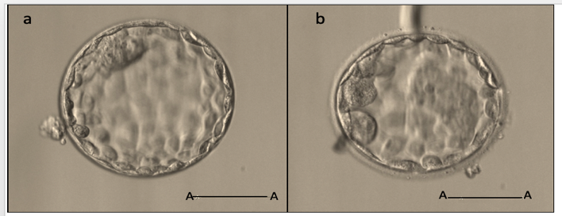

**Figure 1. Good-quality blastocysts:** 5AA is a grade 1 blastocyst with the degree 5 of blastocoel expansion, an ICM “A” grade, and a TE “A” grade (a); 4BB is a grade 2 blastocyst with the degree 4 of blastocoel expansion, an ICM “B” grade and a TE “B” grade (b); scale bar A-A: 50 µm *(IVFMD Phu Nhuan).*

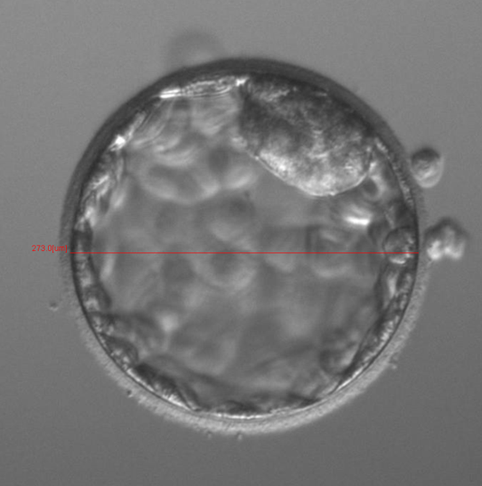

**Figure 2. The maximum diameter (d) of blastocyst** *(IVFMD Phu Nhuan). red line was* **maximum diameter (d) of blastocyst**

**Embryo Frozen and Warming protocol**

Embryos were frozen by vitrified according to the Cryotech (Japan) kit. They were placed into equilibration solution following vitrification solution, then put on cryotecs (Cryotech, Japan) and stored in liquid nitrogen (-196 °C). A good-quality blastocyst was singly vitrified on a cryotec for single blastocyst transfer later.

The warming procedure was performed using a Cryotech warming kit (Japan). After warming, embryos were immediately evaluated for warm morphological survival.

**Frozen embryo transfer**

In a frozen-embryo transfer cycle, patients underwent the process of endometrium preparation by estradiol/progesterone replacement protocol. After an oral estradiol treament period of at least 10 days (from day 2 of menstrual cycle) and when endometrial thickness was $≥$ 8mm, ﻿progesterone (Cyclogest, Actavis) was administered. eSBT was performed 5 days after staring progesterones.

**Outcomes**

The primary outcome was the live birth rate after eSBT. Live birth was identified as the birth of at least one baby after 24 weeks of gestation that showed any sign of life (twins as a single count). Secondary outcomes were the rate of clinical pregnancy, ongoing pregnancy, implantation. Clinical pregnancy was described as pregnancy finding by ultrasound scan at 7 weeks of gestation. Pregnancy with a detectable heart rate after 12 weeks of gestation was ongoing pregnancy.

**Statistical analysis**

Baseline and embryonic data showed in the form of descriptive statistics, such as: mean and standard deviation (SD) for normally distributed variables, median and interquartile range (IQR) for skewed variables, or numbers (%) for categorical variables. Differences between groups were analyzed using one-way analysis of variance (ANOVA) with post hoc ﻿with post hoc Tukey HSD test or Kruskal–Wallis test for normally distributed or skewed variables, respectively, and the Chi-square test for categorical variables.

Blastocysts were divided into four groups based on the interquartile range of their diameter (with cut-offs at the 25th, 50th, and 75th percentiles). Univariable and multivariable logistic regression analyses were performed to find out the correlation of embryos’ kinetic and morphology parameters to live birth. After univariate analysis, the variables with a *p*-value of p < 0.25 were analyzed using multivariable analysis for adjusted p-value. All analyses were performed using the R statistical programme (version 4.1.1). Statistical significance was defined as *p* < 0.05.

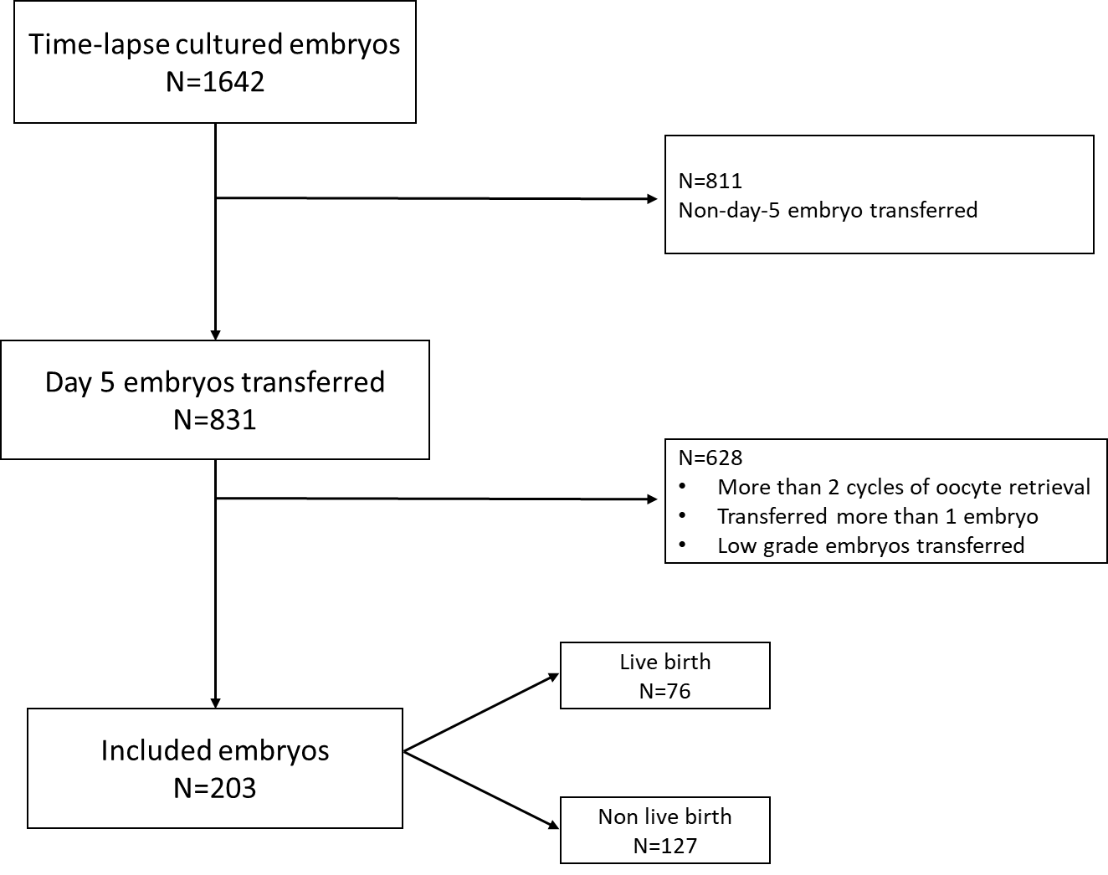

**Figure 3: Flow chart of study**

**Results**

From October 2018 to November 2020, a total of 1,642 embryos were cultured in TLM, and 203 blastocysts met the eligibility criteria. Of those, 76 blastocysts achieved live births, and 127 blastocysts were not successful with non-live births **(Figure 3)**.

The median blastocyst diameter was 167.6µm (149.4 – 180.9µm). Blastocysts were divided into four groups based on the interquartile range of their diameter, comprised of: ≤ 149.4µm (n = 51 embryos), 149.4 – 167.6µm (n = 51 embryos), 167.6 – 180.9µm (n = 50 embryos), 180.9 – 218.2µm (n = 51 embryos). All baseline characteristics showed no significant differences among the four groups. On the other hand, both kinetic parameters (tSB, tB, tEB, dB) and the ICM and TE quality of blastocyst had statistical differences found among the four groups (p < 0.05). There was no significant difference in LB rates among four groups of blastocyst diameter (29.4%, 34.0%, 41.2%, and 45.1%, respectively; p = 0.36); similarly, the rate of clinical pregnancy, ongoing pregnancy, and implantation were the same among groups (**Table 1**).

**Table 1: The baseline and embryonic characteristics of four blastocyst diameter groups**

|  |  |  |  |  |  |
| --- | --- | --- | --- | --- | --- |
| Characteristics | Blastocyst diameter (µm) | | | |  |
| ≤ 149.4µm | 149.4 – 167.6µm | 167.6 – 180.9µm | 180.9 – 218.2µm | P-value |
| N=51 | N=51 | N=50 | N=51 |  |
| Baseline characteristics | | | | | |
| Blastocyst diameter (µm) | 139 [134; 146] | 158 [152; 163] | 171 [168; 175] | 187 [182; 193] | <0.001 |
| Female age (years) | 35.0 [30.5; 37.5] | 34.0 [31.0; 37.0] | 32.0 [30.0;35.0] | 32.0 [29.0;36.5] | 0.12 |
| BMI (kg/m2) | 21.1 [19.6; 22.7] | 21.5 [19.4; 22.6] | 20.3 [19.4;22.2] | 21.2 [19.1;23.2] | 0.49 |
| AMH (ng/ml) | 2.97 [1.77; 5.80] | 2.94 [1.84; 4.62] | 3.43 [2.30;4.37] | 2.88 [1.62;4.34] | 0.77 |
| Infertility duration (years) | 3.0 [2.0; 4.5] | 3.0 [2.0; 5.0] | 4.0 [1.6; 5.6] | 3.0 [2.0; 7.3] | 0.86 |
| ﻿Type of infertility (%) |  |  |  |  | 0.06 |
| ﻿Primary | 30 (58.8%) | 29 (58.0%) | 24 (47.1%) | 18 (35.3%) |  |
| ﻿Secondary | 21 (41.2%) | 21 (42.0%) | 27 (52.9%) | 33 (64.7%) |  |
| ﻿Number of IVF cycles (%) |  |  |  |  | 0.89 |
| 1 | 40 (78.4%) | 37 (74.0%) | 41 (80.4%) | 40 (78.4%) |  |
| 2 | 11 (21.6%) | 13 (26.0%) | 10 (19.6%) | 11 (21.6%) |  |
| ﻿Estradiol levels on day of trigger (pmol/l) | 2,760 [1,652; 5,185] | 2,292 [1,584; 6,878] | 4,412 [1,639; 6,847] | 3,284 [2,305; 5,920] | 0.45 |
| Progesterone levels on day of trigger (pmol/l) | 0.70 [0.53; 1.07] | 1.01 [0.58; 1.36] | 0.90 [0.52; 1.39] | 0.94 [0.65; 1.23] | 0.43 |
| ﻿Endometrial thickness (mm) | 10.5 [9.0; 11.5] | 11.0 [9.3; 11.5] | 11.0 [9.1; 11.4] | 11.0 [10.0; 11.9] | 0.55 |
| Number of oocytes retrieved (n) | 13.0 [10.0; 15.5] | 13.0 [11.0; 16.0] | 14.0 [11.0; 17.0] | 14.0 [11.0; 17.0] | 0.62 |
| Muturation rate (%) | 11.0 [9.0; 13.0] | 11.5 [9.0; 13.8] | 11.0 [9.0; 13.0] | 11.0 [9.0; 14.0] | 0.64 |
| Fertilization rate (%) | 76.9 [67.9; 88.3] | 81.8 [73.3; 90.0] | 81.8 [75.0; 90.5] | 83.3 [71.4; 88.9] | 0.61 |
| Embryonic characteristics | | | | | |
| ICM and TE quality |  |  |  |  | <0.001 |
| A-A | 7 (13.7%) | 7 (14.0%) | 24 (47.1%) | 15 (29.4%) |  |
| A-B | 20 (39.2%) | 27 (54.0%) | 20 (39.2%) | 28 (54.9%) |  |
| B-A | 4 (7.84%) | 4 (8.00%) | 4 (7.84%) | 7 (13.7%) |  |
| B-B | 20 (39.2%) | 12 (24.0%) | 3 (5.88%) | 1 (1.96%) |  |
| tSB (hpi) | 99.4 [96.9; 102.0] | 95.8 [93.2; 98.4] | 93.5 [90.7;95.0] | 89.9 [87.2; 91.9] | <0.001 |
| tB (hpi) | 110.0 [108.0; 113.0] | 105.0 [104.0; 108.0] | 104.0 [101.0; 105.0] | 99.7 [97.1; 102] | <0.001 |
| tEB (hpi) | 113.0 [109.0; 115.0] | 107.0 [105.0; 110.0] | 105.0 [102.0; 107.0] | 101.0 [99.2; 104.0] | <0.001 |
| dB (hpi) | 10.8 [9.5; 11.6] | 9.9 [8.0; 11.4] | 9.7 [8.5; 11.2] | 9.0 [8.0;11.2] | 0.03 |
| Pregnancy outcomes | | | | | |
| Clinical pregnancy | 29 (56.9) | 23 (46.0) | 35 (68.6) | 34 (66.7) | 0.08 |
| Implantation | 29 (56.9) | 20 (40.0) | 31 (60.8) | 27 (56.9) | 0.11 |
| Ongoing pregnancy | 24 (47.1) | 17 (34.0) | 29 (56.9) | 26 (51.0) | 0.08 |
| Live birth | 15 (29.4) | 17 (34.0) | 21 (41.2) | 23 (45.1) | 0.36 |

*Data were shown as mean ± SD, median (IQR), or n (%)*

Good-quality blastocysts with different ICM and TE grades, including: AA (n=53 embryos), AB (n=95 embryos), BA (n= 19 embryos), BB (n= 36 embryos). LB rates of good-quality blastocysts AA, AB, BA, BB in eSBT cycles were 39.6%, 31.6%, 57.9%, and 38.9%, respectively (p = 0.17) (**Table 2**). Multivariate logistic regression revealed that the ICM and TE grade of good-quality blastocysts was associated with LB (OR 3.03, 95%CI: 1.01 - 9.1, p = 0.04) **(Table 3)**. In addition, significant differences were found among good-quality blastocysts when comparing diameter and kinetic parameters (tSB, tB, tEB) (p < 0.001), while dB was no significant difference (p = 0.12).

**Table 2: Diameter and kinetic characteristics of embryos with different ICM and TE combination**

|  |  |  |  |  |  |
| --- | --- | --- | --- | --- | --- |
| Parameters | Quality ICM and TE | | | | |
| AA (n=53) | AB (n=95) | BA (n=19) | BB (n=36) | p-value |
| Live birth n(%) | 21 (39.6) | 30 (31.6) | 11 (57.9) | 14 (38.9) | 0.17 |
| Mean diameter (µm) | 143 [138;150] | 139 [129;149] | 142 [130;150] | 127 [120;131] | <0.001 |
| tSB (hpi) | 93.0 [89.6;94.7] | 94.4 [90.6;97.9] | 92.1 [89.9;97.3] | 98.4 [95.3;100.0] | <0.001 |
| tB (hpi) | 102.0 [99.5; 105.0] | 104.0 [101.0; 108.0] | 102 .0 [99.8; 105.0] | 108.0 [105.0; 111.0] | <0.001 |
| tEB (hpi) | 104.0 [101.0; 106.0] | 106 [103;109] | 103 [101;106] | 112 [106;114] | <0.001 |
| dB (hpi) | 9.9 [8.3; 11.4] | 10.0 [8.3; 11.2] | 8.5 [7.4; 10.3] | 10.8 [8.8; 11.9] | 0.12 |

*Data were shown as mean ± SD, n (%)*

Kinetic parameters were similar in blastocysts, which resulted in LB compared with non-LB (tSB: 94.4 ± 5.0 hpi vs. 94.2 ± 5.2 hpi, tB: 105.0 ± 7.6 hpi vs. 104.0 ± 5.4 hpi, tEB: 106.0 ± 5.6 hpi vs. 105.0 ± 11.0 hpi, dB: 10.6 ± 5.7 hpi vs. 10.9 ± 8.9 hpi, respectively; p > 0.05) (Table 3).

Multivariate logistic regression revealed that there was no correlation between the blastocyst diameter, kinetics and LB when transferring a good-quality blastocyst (d: OR 1.43, 95%CI: 0.72 - 3.14; tSB: OR 1.01, 95%CI: 0.95 - 1.06; tB: OR 1.02, 95%CI: 0.97 - 1.06; tEB: OR 1.00, 95%CI: 0.97 - 1.04; dB: OR 0.99, 95%CI: 0.95 - 1.03); while ICM + TE quality was associated with LB (OR 3.03, 95%CI: 1.01 - 9.1, p = 0.04) (Table 3).

**Table 3: Correlation between morphometric, kinetic parameters and live birth rate analyzed by univariate and multivariate logistic regression**

|  |  |  |  |  |
| --- | --- | --- | --- | --- |
| Parameters | Live birth  (N = 127) | Non-live birth  (N = 76) | OR [95%CI]; p-value | |
| Univariate analysis | Multivariate analysis |
| Baseline characteristics | | | | |
| Female age (years) | 33.7 ± 4.76 | 33.3 ± 4.30 | 0.98 [0.92; 1.05]; 0.57 | - |
| BMI (kg/m2) | 21.2 ± 2.64 | 21.4 ± 2.72 | 1.03 [0.92;1.15]; 0.59 | - |
| AMH (ng/ml) | 3.43 ± 2.15 | 3.52 ± 2.07 | 1.02 [0.88;1.19]; 0.79 | - |
| Infertility duration (years) | 3.84 ± 2.94 | 4.16 ± 3.18 | 1.04 [0.94;1.14]; 0.47 | - |
| ﻿Type of infertility (%) |  |  |  |  |
| ﻿Primary | 65 (51.2) | 36 (47.4) | Reference |  |
| ﻿Secondary | 62 (48.8) | 40 (52.6) | 1.16 [0.66;2.06]; 0.6 | - |
| ﻿Number of IVF cycles (%) |  |  |  |  |
| 1 | 93 (73.2) | 65 (85.5) | Reference |  |
| 2 | 34 (26.8) | 11 (14.5) | 0.46 [0.22;0.98]; 0.04 | 0.47 [0.2;1.1]; 0.08 |
| ﻿Estradiol levels on day of trigger (pmol/l) | 3900 ± 2795 | 4933 ± 5961 | 1 [1.0;1.0]; 0.17 | 1 [1.0;1.0]; 0.3 |
| Progesterone levels on day of trigger (pmol/l) | 1.08 ± 0.74 | 0.98 ± 0.94 | 0.86 [0.57;1.29]; 0.47 | - |
| ﻿Number of IVF cycles (%) | 9.94 ± 2.80 | 10.5 ± 2.03 | 1.1 [0.93;1.29]; 0.26 | - |
| Fertilization rate (%) | 79.1 ± 14.3 | 81.2 ± 13.3 | 1.01 [0.99;1.03]; 0.32 | - |
| Embryonic characteristics | | | | |
| ICM and TE quality |  |  |  |  |
| A-A | 32 (25.2%) | 21 (27.6%) | Reference | Reference |
| A-B | 65 (51.2%) | 30 (39.5%) | 0.7 [0.35-1.42]; 0.30 | - |
| B-A | 8 (6.3%) | 11 (14.5%) | 2.1 [0.73-6.26]; 0.17 | 3.03 [1.01;9.10]; 0.04 |
| B-B | 22 (17.3%) | 14 (18.4%) | 0.97 [0.40-2.30]; 0.90 | - |
| tSB (hpi) | 94.2 ± 5.2 | 94.4 ± 5.0 | 1.01 [0.95-1.06]; 0.80 | - |
| tB (hpi) | 104.0 ± 5.4 | 105.0 ± 7.6 | 1.02 [0.97-1.06]; 0.50 | - |
| tEB (hpi) | 105.0 ± 11.0 | 106 ± 5.8 | 1.004 [0.97-1.04]; 0.79 | - |
| dB (hpi) | 10.9 ± 8.9 | 10.6 ± 5.7 | 0.99 [0.95-1.03]; 0.74 | - |
| Blastocyst diameter (µm) | | | | |
| ≤ 149.4 | 36 (28.3) | 15 (19.7) | Reference | Reference |
| 149.4 – 167.6 | 33 (26) | 17 (22.4) | 1.23 [0.53;2.89]; 0.62 | - |
| 167.6 – 180.9 | 30 (23.6) | 21 (27.6) | 1.68 [0.74;3.87]; 0.22 | 1.58 [0.72;3.48]; 0.25 |
| 180.9 – 218.2 | 28 (22) | 23 (30.3) | 1.97 [0.88;4.53]; 0.10 | 1.43 [0.65;3.14]; 0.37 |

*Data were shown as mean ± SD, n (%)*

**Discussion**

The result of this study showed that there was no correlation between the blastocyst diameter, kinetics and LB when transferring a good-quality blastocyst. Recent studies have shown that the diameter and area of blastocysts in use are positively correlated with blastocyst implantation potential [9]–[11]. According result to a retrospective study performed on 664 patients who had eSBT [10], showed that transferred blastocysts resulting in clinical pregnancy had a significantly larger width and area, larger than that of non-pregnant blastocysts [median (range) 184 μm (125–239) vs 160 μm (120–230); p <0.01; ﻿ 26,099 μm2 (12,101–45,280) 22,251 μm2 (10,992–37,931); respectively]. Univariate logistic regression analysis showed that both blastocyst width [(OR= 1.026, 95% CI = (1.019, 1.033), p <0.01] and area [(OR= 1.00008, 95% CI = (1.00006, 1.00011), p <0.01] were correlated significant with clinical pregnancy. Following result study of Hirata and co-workers [13], reported that the implantation rate for blastocyst diameter groups (<140μm, 140-160μm, 160-180μm, ≥180μm) were 37.1%, 53.9%, 59.1% and 61.3% respectively; while the LBRs were 28.2%, 38.6%, 46.5% and 48.6%, respectively (P<0.05). Furthermore, multivariate logistic regression analysis showed that blastocyst diameter was not significantly associated with LB (<149.4 μm versus 167.6 – 180.9 μm: OR 1.58, 95%Cl 0.72 – 3.48; <140μm versus 180.9 – 218.2 μm: OR 1.43, 95%Cl 0.65 - 3.14).

Furthermore, morphokinetic variables are indentificated from TLM as can bio-markers of implantation potential and live birth after blastocyst transfers [11], [12]. The first report on the tSB and dB parameters that can predict live birth after blastocyst transfer is described by Fishel and collaborators (2018). Blastocysts transferred had tSB ≤ 93.1 hpi and dB ≤ 12.5 h could higher achieve live birth potential [12]. Bori and colleagues (2022), found that implanted blastocysts had shorter parameters of tSB, tB, and tEB when compared to the non-implanted embryo [11]. These studies analyzed morphokinetics on both good-quality blastocysts and poor-quality blastocysts. While, our study only performed on good quality blastocysts group and found that kinetics (comprised of tSB, tB, tEB, dB) were not different among blastocysts achieved LB and non-LB.

﻿Interestingly, the study also recorded that BA blastocysts had the highest LB rates (57.9%) in eSBT cycles when compared with AA, AB, and BB blastocysts (39.6%, 31.6%, and 38.9%, respectively). After multivariate logistic regression analysis revealed that the ICM and TE grade of good-quality blastocysts was associated with LB (OR 3.03, 95%CI: 1.01 - 9.1, p = 0.04). Following result study of Awdalla and co-workers (2021), found TE morphology was a better predictor of live birth rate than ICM morphology; especially the LB rates of BA and CB blastocysts were higher versus AB, BC blastocysts (55% vs. 44%; 32% vs. 15%, respectively) [14]. Contrastingly, other research demonstrated ICM grade was the strongest predictor of live birth [15]. The morphological parameters are the blastocyst expansion stage, ICM grade, and TE grade all associated with live birth. Of those, the parameter that has the highest predictor value of live birth is still controversial.

﻿The limitations of this study included its retrospective design, which only focused on the analysis of the morphometric and kinetics of good-quality blastocysts group in eSBT cycles. Further studies with a prospective design, larger sample sizes, and analysis of different quality blastocysts will be needed to evaluate the correlation between morphometric kinetics and live birth.

**Conclusions**

This study revealed that blastocyst diameter and kinetics (tSB, tB, tEB, dB) of good quality blastocysts were not correlated to live birth. Therefore, when selecting a good morphology blastocyst for transfer, it is no longer necessary to evaluate diameter and kinetic parameters reflecting blastocyst development. Future studies should also investigate the correlation of other kinetic parameters with live birth.

**References**

[1] E. Adolfsson and A. N. Andershed, “Morphology vs morphokinetics: A retrospective comparison of interobserver and intra-observer agreement between embryologists on blastocysts with known implantation outcome,” *J. Bras. Reprod. Assist.*, vol. 22, no. 3, pp. 228–237, 2018.

[2] L. Martínez-Granados *et al.*, “Inter-laboratory agreement on embryo classification and clinical decision: Conventional morphological assessment vs. time lapse.,” *PLoS One*, vol. 12, no. 8, p. e0183328, 2017.

[3] D. K. Gardner and W. B. Schoolcraft, “Culture and transfer of human blastocysts.,” *Curr. Opin. Obstet. Gynecol.*, vol. 11, no. 3, pp. 307–311, Jun. 1999.

[4] J. Subira *et al.*, “Grade of the inner cell mass, but not trophectoderm, predicts live birth in fresh blastocyst single transfers.,” *Hum. Fertil. (Camb).*, vol. 19, no. 4, pp. 254–261, Dec. 2016.

[5] E. Van den Abbeel *et al.*, “Association between blastocyst morphology and outcome of single-blastocyst transfer.,” *Reprod. Biomed. Online*, vol. 27, no. 4, pp. 353–61, Oct. 2013.

[6] J. Zhao, Y. Yan, X. Huang, L. Sun, and Y. Li, “Blastocoele expansion : an important parameter for predicting clinical success pregnancy after frozen-warmed blastocysts transfer,” *Reprod. Biol. Endocrinol.*, vol. 2, pp. 1–8, 2019.

[7] J. B. Bakkensen, P. Brady, D. Carusi, P. Romanski, A. M. Thomas, and C. Racowsky, “Association between blastocyst morphology and pregnancy and perinatal outcomes following fresh and cryopreserved embryo transfer,” *J. Assist. Reprod. Genet.*, vol. 36, no. 11, pp. 2315–2324, 2019.

[8] S. M. Thompson, N. Onwubalili, K. Brown, S. K. Jindal, and P. G. McGovern, “Blastocyst expansion score and trophectoderm morphology strongly predict successful clinical pregnancy and live birth following elective single embryo blastocyst transfer (eSET): A national study,” *J. Assist. Reprod. Genet.*, vol. 30, no. 12, pp. 1577–1581, 2013.

[9] M. Almagor, Y. Harir, S. Fieldust, Y. Or, and Z. Shoham, “The ratio between inner cell mass diameter and blastocyst diameter is correlated with successful pregnancy outcomes of single blastocyst transfers,” *Fertil. Steril.*, no. August, pp. 1–6, 2016.

[10] R. Sciorio, D. Thong, K. J. Thong, and S. J. Pickerin, “Clinical pregnancy is significantly associated with the blastocyst width and area,” *J Assist Reprod Genet*, vol. 38, no. 4, pp. 847–855, 2021.

[11] L. Bori *et al.*, “Novel and conventional embryo parameters as input data for artificial neural networks: an artificial intelligence model applied for prediction of the implantation potential,” *Fertil. Steril.*, vol. 114, no. 6, pp. 1232–1241, 2020.

[12] S. Fishel *et al.*, “Time-lapse imaging algorithms rank human preimplantation embryos according to the probability of live birth,” *Reprod. Biomed. Online*, vol. 37, no. 3, pp. 304–313, 2018.

[13] H. N. R. Hirata, S. Inoue, K. Taguchi, H. Toshihiro, “P-177 Blastocyst diameter is an important parameter for predicting live birth in frozen single blastocyst transfer cycles,” in *Abstracts of the 34th Annual Meeting of the ESHRE, Barcelona, Spain 1 to 4 July 2018*, 2018, p. i222.

[14] M. Awadalla, A. Kim, N. Vestal, J. Ho, and K. Bendikson, “Effect of age and embryo morphology on live birth rate after transfer of unbiopsied blastocysts,” *J. Bras. Reprod. Assist.*, vol. 25, no. 3, pp. 373–382, 2021.

[15] J. Ai, L. Jin, Y. Zheng, P. Yang, B. Huang, and X. Dong, “The Morphology of Inner Cell Mass Is the Strongest Predictor of Live Birth After a Frozen-Thawed Single Embryo Transfer,” *Front. Endocrinol. (Lausanne).*, vol. 12, no. February, pp. 1–10, 2021.